**Black and Golden Butterflies Abstract Metal Art**

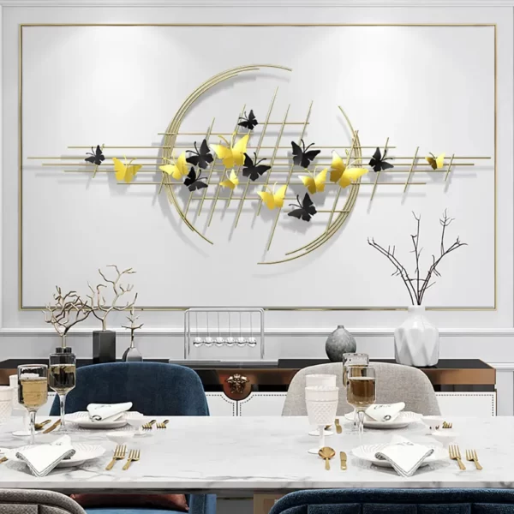Black and golden butterflies abstract metal art is a mesmerizing decor piece that combines elegance and nature-inspired beauty. Featuring intricately crafted butterflies in sleek black and radiant gold tones, this artwork captures a sense of movement and grace. The contrast between the bold black and shimmering gold creates depth and sophistication, making it an eye-catching focal point. Perfect for living rooms, bedrooms, or hallways, this abstract metal art adds a touch of luxury and charm to any space. Its timeless design and meticulous craftsmanship ensure it blends seamlessly with both contemporary and classic interiors.